World Empires/Civilizations Mini-Project
Empire: _________________________________________
Chapter in book: ____________________________________
Study guide questions: ________________________________

Task Checklist:
- In your groups, read the related sections of the World History Text book and fill out the following GSPRITE chart for your empires.
- Using google slides, create a PowerPoint depicting the GSPRITE for the empires you studied. Each slide should contain the following:
- At the top, state the aspect of civilization (Geography, Social structure, Political structure, etc.)
- List 1-2 bullet points for each civilization explaining what this aspect of civilization looked like in this society.
- Each civilization should be on the same slide. For example: (sample)
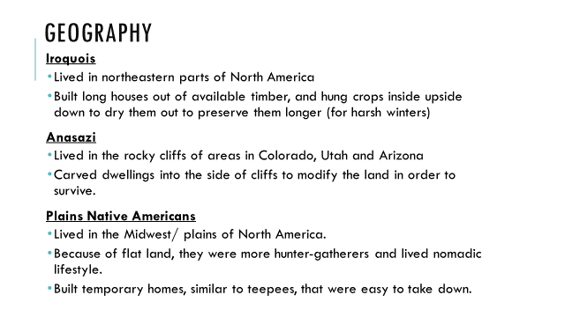
  - You can also add pictures on an additional slide to show your classmates what you’re referring to.
- Next, answer the designated Study Guide questions, on your PowerPoint. Type the question and the answer on a slide (one slide for each question), to help your classmates get the answers as well.
  - *Ms. Alston will tell you which questions to include in PowerPoint from the study guide.
- Finally, prepare 1-3 multiple choice questions to quiz your classmates about on Monday, after you present. These must be turned in on paper to Ms. Alston today by the end of class so she can make the quiz.

Presentations due Monday, March 27th, 2017

