Unit 2: Empires (Rise and Fall of Major World Empires)
Unit 2 Packet Due on Test Day, March 17th, 2013

Part 1: Reading Focus Questions
Directions—Read chapters 1 through 4 and Answer ALL the “Reading Focus Questions” located on the first page of each section.

Chapter 5:
- Pg. 127 #’s 1—3
- Pg.134 #’s 1—4
- Pg. 142 #’s 1—3 \
- Pg. 150 #’s 1—3
Chapter 6:
- Pg. 163 #’s 1—3
- Pg. 171 #’s 1—3
- Pg. 177 #’s 1—2
- Pg. 183 #’s 1—4
- Pg. 188 #’s 1—3

Part II: Vocabulary
Directions—Define the words, concepts, or ideas located in the Concepts/Vocabulary Section of your Unit overview sheet. For each term, define the term, explain why it is important, and draw some symbol or picture to represent the term.
Example:
- Term: “Peloponnesian War”
- Definition: War between Athens (and their allies in Delian League) and Sparta (and their allies in the Peloponnesian league). Sparta ends up winning this war and destroying the Athenian empire, however, no one is truly victorious.
- Significance: This war weakened the two most powerful city-states in ancient Greece; Athens and Sparta. Because of this, both sides being either defeated or utterly exhausted, a new power was able to arise, Macedonia. This eventually paves the way for Alexander the Great. Had this war never happened, who’s to say how great of an empire Alexander could’ve had, if he had to compete with Athens or Sparta.
- Illustration: (you can draw this, cut out a picture, or if you type your definitions, use a computer image)
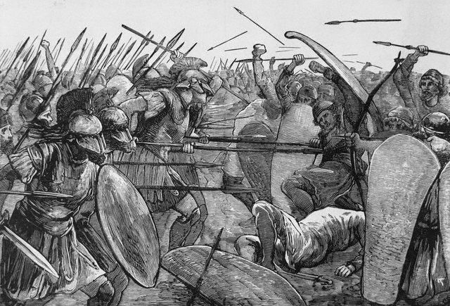
Part III: Map
Directions: On the map provided, label all the major places so that you have an awareness of where these civilizations are geographically. Label each civilization a different color, and distinguish rivers and bodies of water using blue. Create a key for your map as well as a title.

Places to label:

- Greece
- Athens
- Sparta
- Mediterranean Sea
- Rome
- Sicily
- Carthage

Places to outline and shade:

- Alexander the Great’s Empire
- Roman Empire
- Mongol Empire
- Mughal Empire
- Ottoman Empire
- Ming Empire
- Maya Empire
- Inca Empire
- Aztec Empire
- Songhai Empire
- Mali Empire
- Ghana Empire
- Aksum Empire
- Safavid Empire
- Byzantine Empire

Essential Vocabulary for Unit 2:

- Polis
- Democracy
- Cleisteneses
- Direct democracy
- Phalanx
- Pericles**
- Socrates
- Plato
- Aristotle
- Herodotus
- Alexander the Great
- Hellenistic Culture
- Republic
- Plebeians/Patricians
- Twelve Tables
- Julius Caesar
- Constitution
- Senate
- Consul
- Dictator
- Triumvirate
- Caesar Augustus
- Ptolemy
- Aqueducts
- Christianity
- Jesus (Messiah)
- Diocletian
- Slash-and burn agriculture
- Bantu
- Ezana
- Swahili
- Mansa Musa
- Sunni Ali
- Genghis Khan
- Marco Polo
- Akbar the Great
- Taj Mahal

Unit 2 Timeline
Group Assignment day Ancient Greece Intro
Ancient Greece
Ancient Greece
Ancient Greece Quiz  Intro to Ancient Rome | Quiz
Ancient Rome
Quiz on Rome/ Intro to Project Presentations | Quiz
Presentations
Presentations
Review Day
Test Day Unit 2B: Empires | Packets Due
Group Assignment day Ancient Greece Intro
Ancient Greece
Ancient Greece
Ancient Greece Quiz  Intro to Ancient Rome | Quiz
Ancient Rome
Quiz on Rome/ Intro to Project Presentations | Quiz
Presentations
Presentations
Review Day
Test Day Unit 2B: Empires | Packets Due

Name: Rise, Fall & Significance of World Empires Project
Date:
Part IV
Your Empire: _______________________________________________________ Corresponding Chapter: _______________________________

WH.H.2.4 Analyze the rise and spread of various empires in terms of influence, achievements and lasting impact (e.g., Mongol, Mughal, Ottoman, Ming, Mesoamerica, Inca, Imperial states in Africa, etc.)

Directions: You and your learning team will research one influential empire and identify the GSPRITE for that empire, including key people, trading and resources, religions, languages, and contributions to the world at large. You must fulfill the following requirements, as well as adhere to the attached rubric.
Task #1: Research you empire, and identify the GSPRITE of the civilization. Utilize your text book as well as selected resources from the library. In your research, make special note to identity key people as well as key components of GSPRITE. Explain at the bottom of each section of GSPRITE what the significance was of this aspect of the civilization. MINIMUM of 5 facts per category.
Task #2: Answer the following questions about your civilization:
- The Reading focus questions that relate to your civilizations in your text book that relate to your empire. These you will turn into me. You should also maybe incorporate this information into your PowerPoint somewhere.
Task #3: You should create a flow chart depicted the rise and fall of your empire, that incorporates descriptions of what took place from the beginning to the end of your selected empire. You can also make a story board instead telling the story of your empire, for extra credit***.
Task #4: You must create one of the following cultural elements for your project:
- Create an art piece to represent your empire’s culture. It can be a hand-drawn picture, a painting, a battle mask, a building construction, a hand-drawn map, a piece of jewelry, or an actual artifact from this region if someone in your group has one. Be creative. The most important aspect of this section is to make sure it’s your own work; not that found on a computer.
- Come to class on the day of your presentation dressed in authentic or traditional attire based on the people of your empire. You must be tasteful, authentic, and appropriate. If you look messed or your presentation is not an accurate representation of the people within your empire, you will receive a “0”.
- You may prepare a dish or bring something to eat that reflects your specified culture. You must bring enough for each of your classmates to at least sample the food, as well as a list of the ingredients (to help students with allergies).
Task #5: Current Event. You must research a current event from the world today, or that has occurred within the last year, that relates to the information you will be presenting or that you have learned about your empire. You must write a summary of this event and identify its impact on the region
Task #6: You must create a PowerPoint to display the GSPRITE characteristic of your empire, as well as the answers to the questions in number 2. There must be a minimum of 5-7 pictures. You cannot have more than 5 bulleted points per slide with no more than 7 words per bullet. You must utilize spell-check, and make sure your visuals are the correct size. If you stretch the image and it becomes blurry for your audience you will lose points.
Task #7: Your presentation. Each member of your group must speak during your presentations. You must practice what you are going to say, as well as prepare index cards to aid in your presentation. You must dress professionally or your will lose 10 points individually. You must make eye-contact and speak to your audience’ not solely read from the PowerPoint.
PowerPoint presentation structure should be as follows:
- Title page: including group members’ names and project due date: Thursday October 18th, 2013
- Introduction page: introducing your topic. Explain how this empire rose to power here.
- Next slides should be the GSPRITE information. Follow format explained above.
- Explanation of the decline of the empire.
- Major contributions of this empire/ Lasting Legacies
- Current Event information
**Include a map of this region somewhere during the presentation—it doesn’t matter where**
This will count as a TEST and PROJECT grade. There will be people from outside the school as well as other adults viewing your presentations and grading you on your performance. Do your BEST work!

