Name: Date:
Unit 9 Test –Development
Directions: Choose the best answer for the following questions. Please provide a reason for your answer. If explanation isn’t sufficient, points will be deducted.
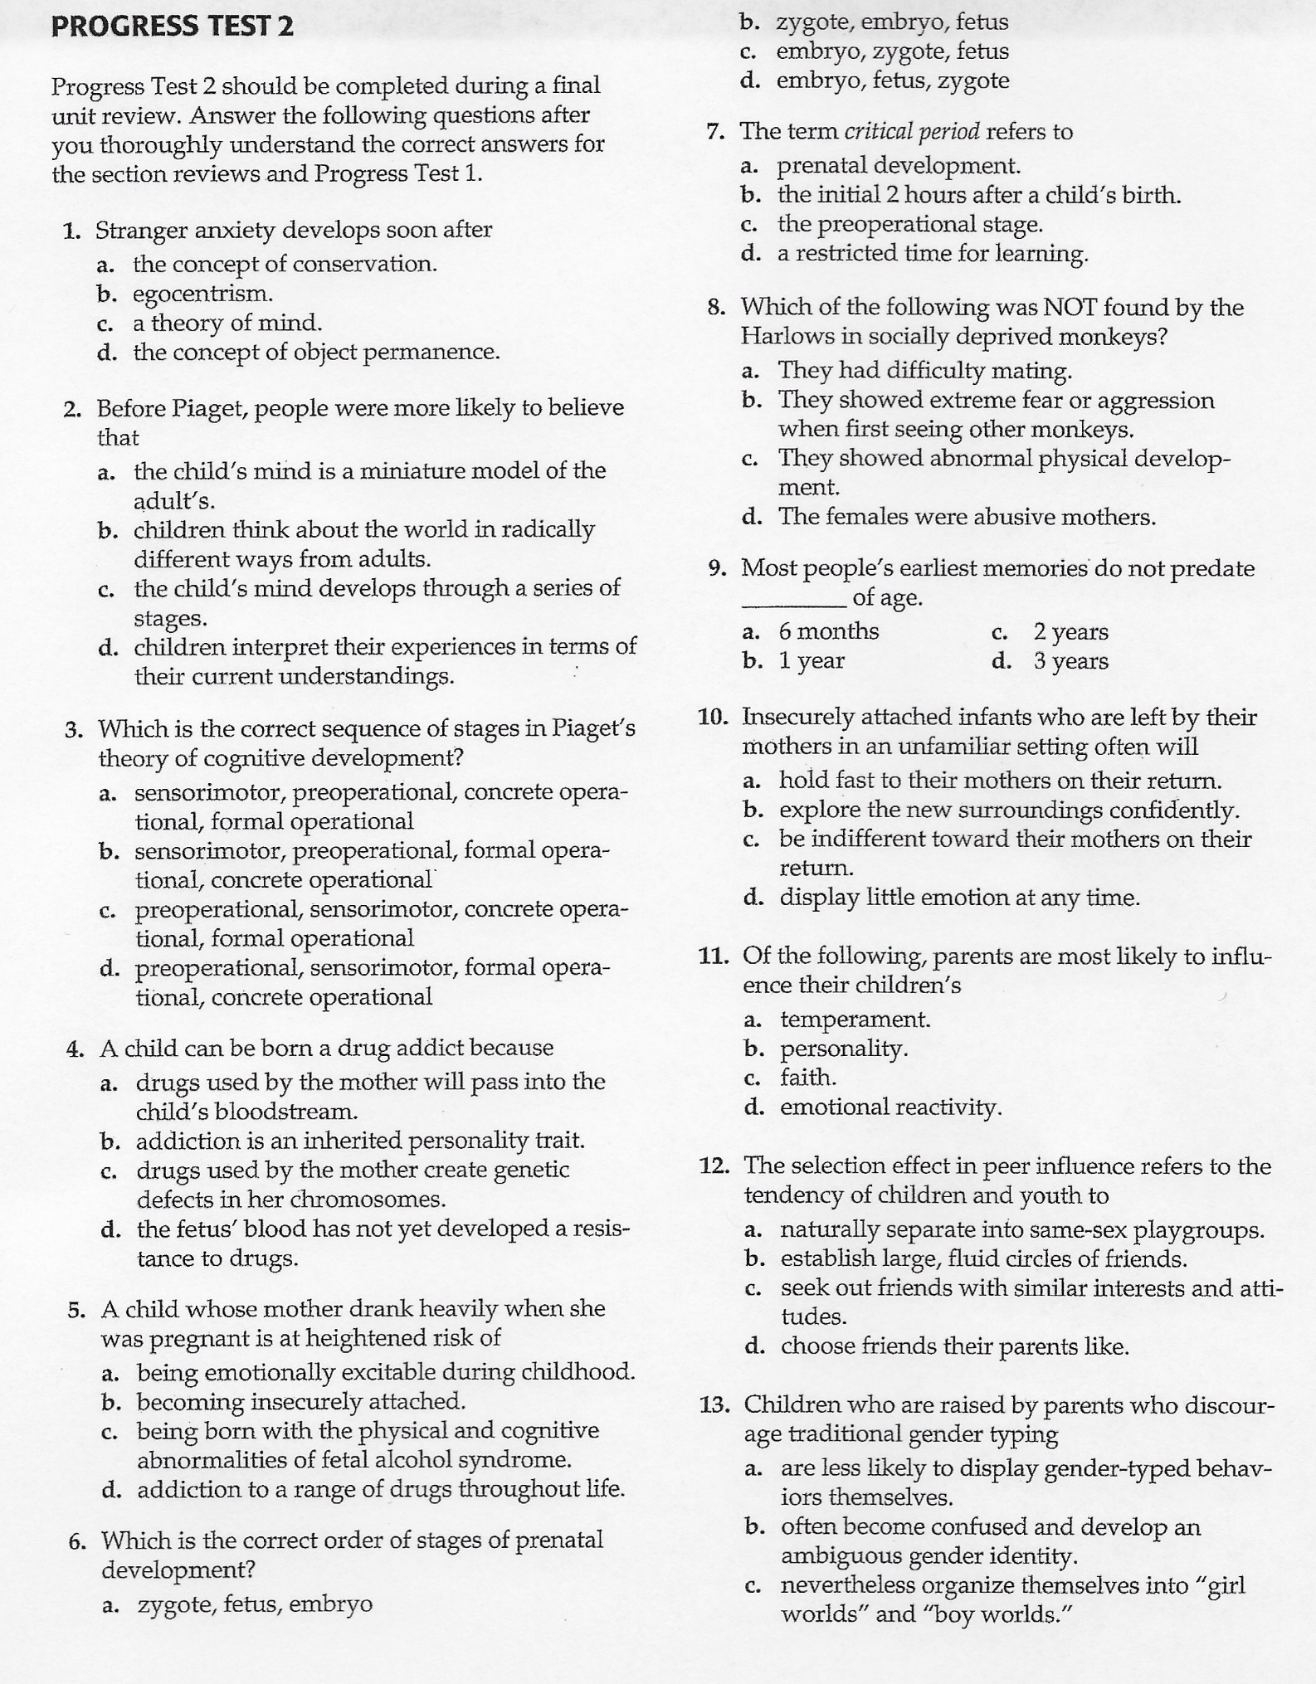

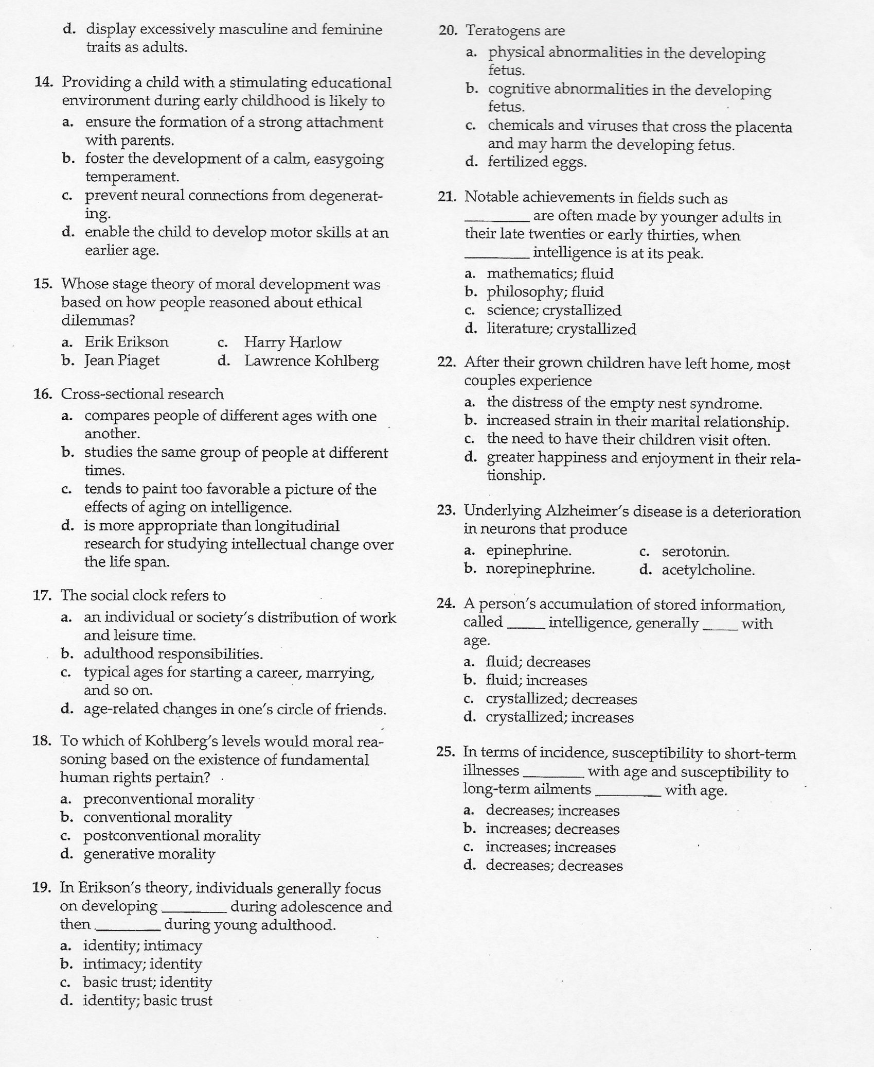

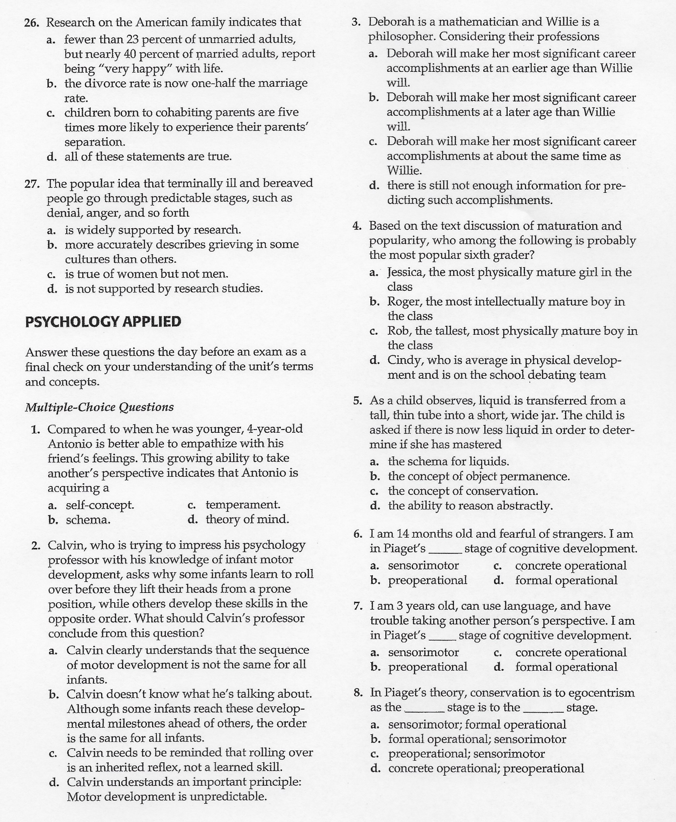

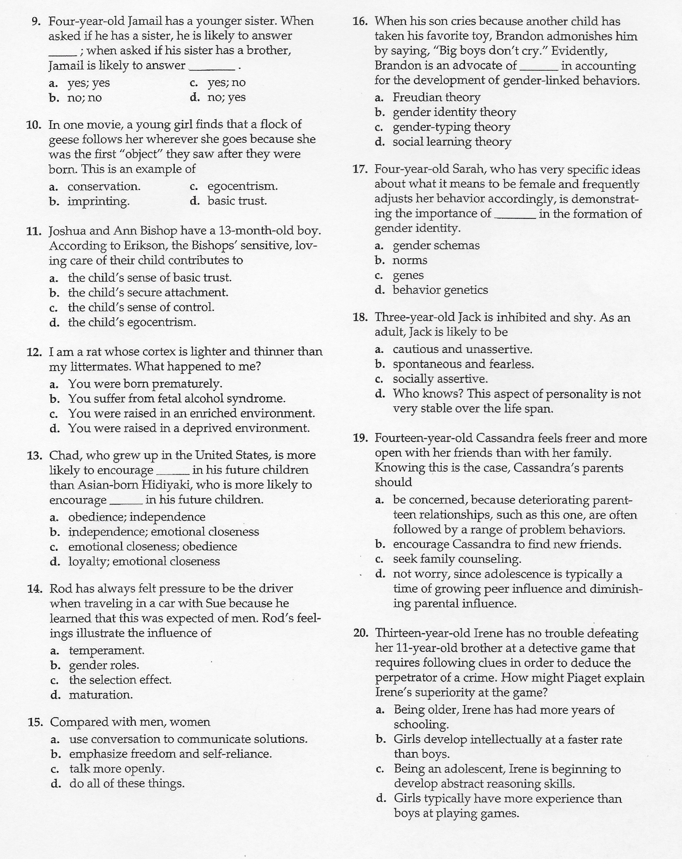

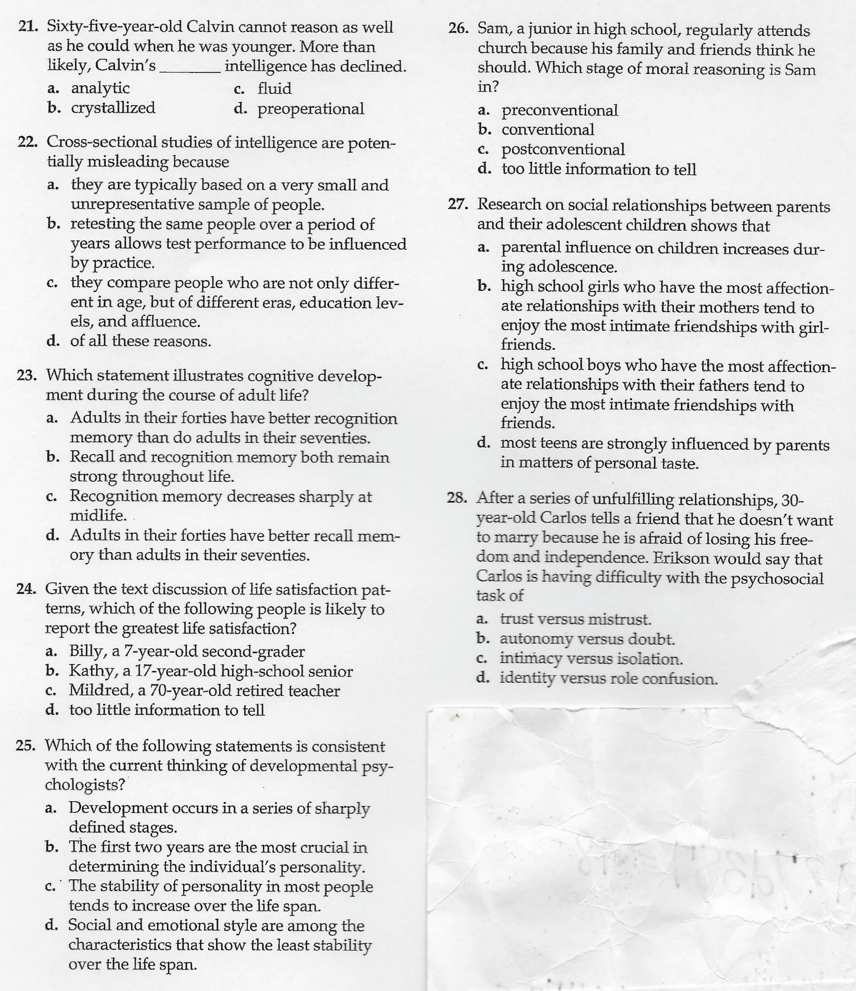

Your FRQ will be a research paper instead, (because I didn’t like any of the previous FRQ’s). You will be able to complete this in class on Wednesday when I’m not there. You are to view the PowerPoint located on the class website about Lev Vygotsky. Then, using what you learn as well as outside sources, you are to write a 2-4 page paper, double space, comparing and contrasting the views of Vygotsky and Jean Piaget. You need to:
- First, summarize their theories
- Then discuss key differences in the theories
- Finally, explain what we can gain from understanding these theories today.
If you use other sources, you need to include a reference section at the end of your paper or else you’ll get a zero “0” for plagiarism. This assignment must be typed and submitted online by Friday, January 6th, by 11:59 pm. You must use the “research paper” submission option on the class website to submit your papers.

