Name: Date:
World History_Alston

The Scramble for Africa
Answer the following questions based on the Scramble for Africa cartoon
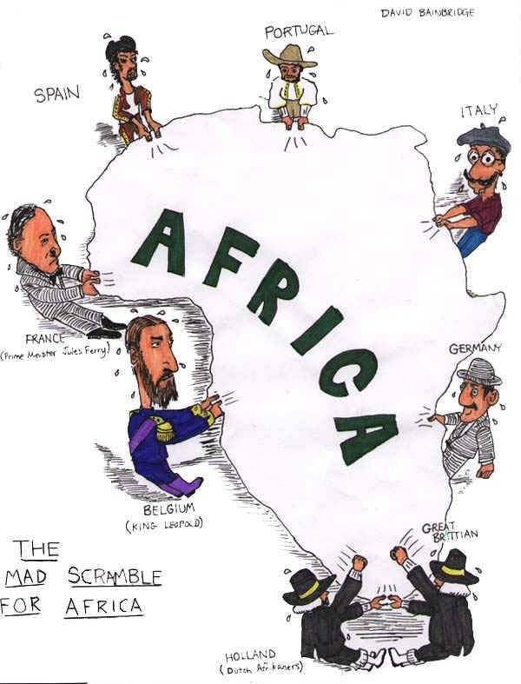
- According to the cartoon, which European countries were fighting for a position in Africa?

2. How did the Berlin Conference lead to the situation shown in this cartoon?

AFRICA MAP COMPARISON
Examine the Maps below. Then answer the questions that follow
MAP 1

MAP 2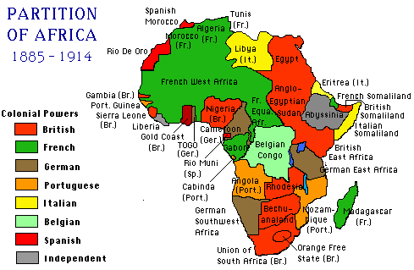
above maps from http://fresno.k12.ca.us/schools/s090/lloyd/imperialism.htm
1. What is the main difference between the 2 maps?
2. What part did the Berlin Conference play in the creation MAP 2?
3. What happened to the native African political entities by 1914?
4. According to Map 2-- Which 2 European countries held the most territory in Africa?

