Name:
Date:
AP Psychology w/ Alston

Development Magazine Project
Directions: You are to design a magazine geared towards a specific developmental age group: either the parents of young children ages newborn- 10, adolescents ages 11-18, young adults ages 20-30, middle-aged adults ages 40-60, or senior citizens ages 60+. You are to include all of the following portions in your magazine in order to receive full credit. Your magazine should be typed, colorful, printed out and made to look like a real magazine. It should reflect extensive effort and understanding of concepts for development. Requirements are follows:
- _____ You must decide on the age group you are selecting to design a magazine around. Then you much narrow your developmental age group down further to choosing a particular issue that this age group faces that you want to address. For example: If you choose children ages 1-12, you would make a magazine geared towards their parents. So, if you created a focus for you magazine, your theme may be Healthy kids: Addressing childhood obesity.
Another example could be if you addressed Middle adulthood, ages 40-60, you may focus on “getting your second wind in life”, discussing ways to reinvent yourself once the kids are gone and they’ve spent many years in a certain job or career.

- _____ Your magazine must have a title that best suites your target audience. On the cover of your magazine you must have:
  - The title
  - A picture relating to the subject matter and focus of your magazine. This could be a picture of someone or some issue featured in the magazine, an issue in the world relating to your target audience, etc.
  - On the side in smaller print, a few feature articles or topics discussed in your magazine.
  - An issue number, or date. (you can make this up)

- _____ Your magazine must contain on the next page, page 2, a table of contents. Just like in areal magazine, you should let your reader know on what page they can find information and specific articles and stories. Examples may be:
  - Issues and Views—addressing controversial topics that can make your reader form their own opinions. **Editorial can be here.
  - Features
  - Interviews, etc.

- _____ Your magazine must contain at least 4-5 advertisements throughout the magazine that are spaced out within the pages of your content and other articles and stories. These advertisements are VERY important because they should be appropriate for the target audience of your magazine. You wouldn’t see an advertisement for depends or dentures in a magazine for parents of children from 1-12. You should choose to advertise products, events, or causes that fit with the flow of your magazine, and would be of interest and beneficial to your target audience. Good Example: if your magazine focuses on children’s health, you may advertise new brands of healthy snack substitutes that parents may want to try with their kids.

- _____ Your magazine must contain a feature story, that addresses the focus of you magazine. If you refer back to the example of child nutrition, focusing on childhood obesity, a feature article could be about the “epidemic of childhood obesity”. You could talk about the ethnic groups that suffer the most from obesity, reasons why, why is obesity a problem, and what can be done to prevent this from happening to “your” child. **This portion of the magazine will require you to research various issues that your target audience or group faces in today’s time, and effectively present that issue to your readers.

- _____ Your magazine must contain an interview with someone relevant to this age-group and issues your magazine addresses. The interview can be with an actual person, or hypothetical, but the point of this section is to provide a person, “inside-look”, to the lives of this ages group, and how people are dealing with your chosen issue. Example: referring back to middle-aged adults finding their “second wind in life”, maybe you could interview a parent or someone who has changed their careers, decided to change their habits, lives, started traveling and doing all the things they never had a chance to do, etc, and discuss how that has changed their life.

- _____ Your magazine should include an advice or tip section, that includes a catchy section that give 1-5, 1-10 tips that help your reader achieve the better alternative to your issue or focus in their lives. Example, referring to the middle age adult example, you may include a “10 ways to Make the Most of Life…..Twice!” and include 10 things your group decides would be tips of how a middle aged adult could reinvent themselves and find activities to engage in that give them that “second wind”.

- _____ Your magazine should include an editorial page. This should be done by the editor and it should be an opinionated piece expressing his/her views, or the collected opinion of the group on the main focus of your magazine. This should be heartfelt and reflect an understanding of the issues. This section should be an attempt to persuade your audience that the issues raised in your magazine are important and the how they reflect the best way to approach life and why.

- In any section of your magazine, you need to address Erik Erikson’s Social Development Theory directly for YOUR age group specifically.

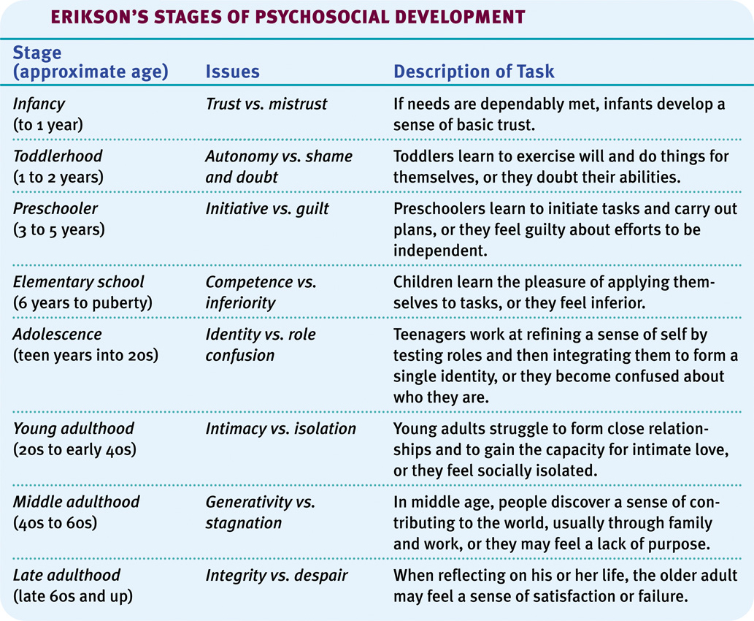

Please work hard and do your best. Push yourselves to utilize technology in its most advances forms. Play with fonts and various programs such as publisher or PowerPoint. Manipulate text and images, resize pictures, use color, enhance fonts, etc. Remember it’s about effort, content, appropriateness, and a demonstration of your understanding of course content. The details ALWAYS matter. This project will count not only as a project grade but also as a quiz grade and will be due at the LATEST, on Thursday, April 16th, 2015

DEVELOPMENT MAGAZINE RUBRIC
OVERALL APPEARANCE | - target audience represented  always  - theme consistent  - font superior and consistent  - generally inviting  -high degree of creativity | - target audience given some  thought  - theme consistent  - font good and consistent  - generally good  - creative | - target audience inconsistent  - theme inconsistent  - font adequate  - generally adequate  - somewhat creative | - target audience forgotten  - no theme evident  - font inadequate  - poorly done  - shows little creativity
COVER | - highly creative  - excellent title  - effective image included  - fits theme of magazine very  well  - very attractive | - creative  - good title  - good choice of image  - fits theme of magazine well  - inviting | - somewhat creative  - adequate title  - image included  - adequately suited to theme  of magazine  - adequate | - shows little creativity  - poor choice of title  - poor choice of image  - theme unclear  - poorly done
CONTENT | - included minimum of 9  components.  - all components are  completed as assigned  - excellent variety of topics  - an illustration included with  each component  - well written | - included minimum of 9  components  - most components completed as  assigned  - good variety of topics  - most components are  illustrated.  - well written  - fewer than minimum of five  components. | - included minimum of 9  components.  - did not include one of each  as assigned.  - adequate variety of topics  - most components are  illustrated  - writing adequate | - fewer than minimum of 9  components.  - some articles completed as  assigned.  - some illustrations  - writing adequate
ILLUSTRATIONS/pictures | - included a minimum of 10 (including advertisements.  - all graphics are connected to  theme.  - highly creative  - excellent color and  composition. | - included a minimum of 10 (including advertisements)  - most graphics connected to  theme  - very creative  - good color and composition | - included a minimum of 10  - artwork not always  connected to theme  - lacks originality  - some color and graphics  elements used. | - less than 10  - seldom connected to theme  - mostly reproductions  - few or no graphic elements.
PRESENTATION | - use of writing process  evident  - correct spelling  - correct grammar  -correct sentence, paragraph  and essay structure  - inviting headlines | - use of writing process evident  - minor spelling errors  - minor grammatical errors  - minor errors in construction  of sentences, paragraphs and  essays.  -good headlines | - careless use of writing  process.  - minor spelling errors  - minor grammatical errors  - written work lacks  organization  - headlines included | - first draft is only draft.  - major spelling errors.  - major grammatical errors.  - lacks organization, disjoint,  and lacks unity.  - some headlines included.

