Ancient China—The Civil Service
What was it?
In Ancient China the government was run by the civil service. There were thousands of civil servants throughout the empire who reported in to the Emperor. The top civil servants were ministers who reported directly to the Emperor and worked in the palace. Ministers were wealthy and powerful government officials.
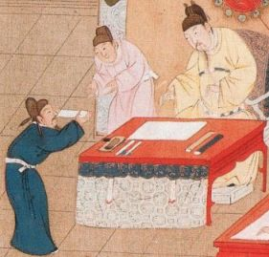
Student taking the Civil Service Exam
When did it start?
The civil service was started during the Han Dynasty in 207 BC by the first Han Emperor, Gaozu. Emperor Gaozu knew that he could not run the entire empire by himself. He decided that highly educated ministers and government administrators would help the empire to become strong and organized. Thus began the civil service that would run the Chinese government for over 2000 years.
Examinations
In order to become a civil servant, people had to take tests. The better they did on the tests, the higher position they could get in the civil service. The examinations were very difficult. Many people would study at the imperial university or under tutors for years in order to pass the tests. A lot of the tests covered the philosophy of Confucius and required lots of memorization. Other subjects included the military, mathematics, geography, and calligraphy. Some tests even involved having to write poetry.
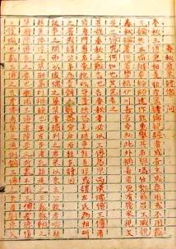
A copy of an old exam
There were nine different levels or ranks of civil service. People could move to a higher rank by passing the next level of examinations. Only a very few of the brightest subjects were able to rise all the way to rank nine. These men became powerful and wealthy. The rank of an official could be determined by the type of badge they wore on their robe. Each rank had the picture of a different bird on their badge.
What did they do?
Civil servants helped to run the government. They had various jobs. The highest ranks worked in the palace and reported directly to the empire. These officials would have control over large areas of the empire. Other officials worked in local districts. They would collect taxes, enforce laws, and act as judges. They also kept the local census and often taught or managed local schools.
Was it a good job?
Working in the civil service was considered an excellent career and one of the most honorable in all of China. Only the rich could afford the education needed to pass the test and only men were allowed to take the tests. Even so, it is thought that at one point so many people were trying to get into the civil service that the chances of passing and getting a job were about 1 in 3,000.
Interesting Facts
- A prefect was responsible for a town and its surrounding farms. Prefects were sort of like mayors today.
- There were various uniforms and ways of determining rank depending on the era or dynasty. These included badges, hats, and necklaces.
- It is estimated that the number of officials in the civil service was well over 100,000.
- Cheating on the exams was met with harsh penalties including death.
- The civil service was an effort to establish a meritocracy. This means that people were promoted due to their "merit" or how well they scored on the exams and not based on their family or wealth. However, most of the officials came from wealthy and powerful families

